**PF LAB WORK 5**

[BY LINTA AFFAF]

[BSSE:1st SEMESTER]

SELF SUPPORT



**CHAPTER 6**

**EXERCISE AND EXAMPLES**

**QUESTION NO 1**

**#include <iostream>**

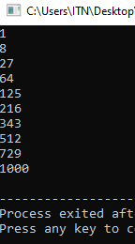**using namespace std;**

**int cube(int y);**

**int main()**

**{**

**int x{0};**

**for (x = 1; x <= 10; x++)**

**{**

**cout << cube(x) << endl;**

**}**

**}**

**int cube(int y)**

**{**

**return y * y * y;**

**QUESTION NO 2**

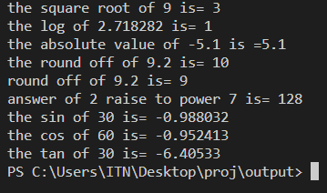

**#include <iostream>**

**#include <cmath>**

**#include <iomanip>**

**using namespace std;**

**int main()**

**{**

**cout <<"the square root of 9 is= "<< sqrt(9) << endl;**

**cout <<"the log of 2.718282 is= "<< log(2.718282) << endl;**

**cout <<"the absolute value of -5.1 is ="<< fabs(-5.1) << endl;**

**cout <<"the round off of 9.2 is= " <<ceil(9.2) << endl;**

**cout <<"round off of 9.2 is= "<< floor(9.2) << endl;**

**cout <<"answer of 2 raise to power 7 is= "<<pow(2,7)<<endl;**

**cout<<"the sin of 30 is= "<<sin(30)<<endl;**

**cout<<"the cos of 60 is= "<<cos(60)<<endl;**

**cout<<"the tan of 30 is= "<<tan(30)<<endl;**

**return 0;}**

**QUESTION NO 3**

**#include <iostream>**

**#include <cmath>**

**using namespace std;**

**const double PI{3.14};**

**inline double sphereVolume(const double radius)**

**{**

**return (4.0/3.0)*PI*pow(radius,3);**

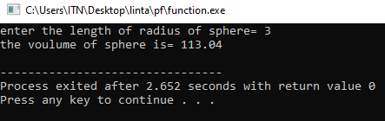

**}**

**int main()**

**{**

**cout << "enter the length of radius of sphere= ";**

**double radiusValue;**

**cin>>radiusValue;**

**cout<<"the voulume of sphere is= "<<sphereVolume(radiusValue)<<endl;**

**return 0;**

**}**

**QUESTION NO 4**

**#include<iostream>**

**using namespace std;**

**double calculate_area(double length,double breadth)**

**{**

**double area=length*breadth;**

**return area;**

**}**

**main ()**

**{**

**double length=5.0;**

**double breadth=3.0;**

**double result= calculate_area(length,breadth);**

**cout<<"the area of the rectangle="<<result<<endl;**

**return 0;**

**}**

**b)**

**#include<iostream>**

**using namespace std;**

**double calculate_circumference(int radius)**

**{**

**double circumference=2*3.14*radius;**

**return circumference;**

**}**

**main ()**

**{**

**int radius=5;**

**double result= calculate_circumference(radius);**

**cout<<"the circumference of the circle="<<result<<endl;**

**return 0;**

**}**

**c)**

**#include<iostream>**

**using namespace std;**

**int convertToInteger(double number)**

**{**

**int result=static_cast<int>(number);**

**return result;**

**}**

**main ()**

**{**

**double number=3.14;**

**int convertednumber=convertToInteger(number);**

**cout<<"the converted number="<<convertednumber<<endl;**

**return 0;**

**}**

**d)**

**#include<iostream>**

**using namespace std;**

**void display()**

**{**

**cout<<"This is the display function!";**

**}**

**main()**

**{**

**display();**

return 0;

}

**QUESTION NO 5**

**#include <iostream>**

**#include <cmath>**

**using namespace std;**

**// Function to round a number to the nearest integer**

**int roundToNearestInteger(double num) {**

**return static_cast<int>(round(num));**

**}**

**int main() {**

**int n;**

**// Prompt user for the number of values to process**

**cout << "Enter the number of values to process: ";**

**cin >> n;**

**// Process each number**

**for (int i = 0; i < n; ++i) {**

**double originalNumber;**

**// Prompt user for input**

**cout << "Enter a number: ";**

**cin >> originalNumber;**

**// Round the number using the roundToNearestInteger function**

**int roundedNumber = roundToNearestInteger(originalNumber);**

**// Print the original and rounded numbers**

**cout << "Original number: " << originalNumber <<endl;**

**cout << "Rounded number: " << roundedNumber <<endl;**

**}**

**return 0;**

**QUESTION NO 6**

**#include <iostream>**

**#include <cmath>**

**using namespace std;**

**// Function to round a number to the nearest integer**

**int roundToNearestInteger(double num) {**

**return static_cast<int>(round(num));**

**}**

**int main() {**

**int n;**

**// Prompt user for the number of values to process**

**cout << "Enter the number of values to process: ";**

**cin >> n;**

**// Process each number**

**for (int i = 0; i < n; ++i) {**

**double originalNumber;**

**// Prompt user for input**

**cout << "Enter a number: ";**

**cin >> originalNumber;**

**// Round the number using the roundToNearestInteger function**

**int roundedNumber = roundToNearestInteger(originalNumber);**

**// Print the original and rounded numbers**

**cout << "Original number: " << originalNumber <<endl;**

**cout << "Rounded number: " << roundedNumber <<endl;**

**}**

**return 0;**

**}**

**QUESTION NO 7**

**#include <iostream>**

**#include <cmath>**

**using namespace std;**

**// Function to round a number to the nearest integer**

**int roundToInteger(double num) {**

**return static_cast<int>(round(num));**

**}**

**// Function to round a number to the nearest tenth**

**double roundToTenths(double num) {**

**return round(num * 10) / 10.0;**

**}**

**// Function to round a number to the nearest hundredth**

**double roundToHundredths(double num) {**

**return round(num * 100) / 100.0;**

**}**

**// Function to round a number to the nearest thousandth**

**double roundToThousandths(double num) {**

**return round(num * 1000) / 1000.0;**

**}**

**int main() {**

**double number;**

**// Prompt user for input**

**cout << "Enter a number: ";**

**cin >> number;**

**// Call each rounding function and print the result**

**cout << "Original number: " << number << std::endl;**

**cout << "Rounded to nearest integer: " << roundToInteger(number) <<endl;**

**cout << "Rounded to nearest tenth: " << roundToTenths(number) <<endl;**

**cout << "Rounded to nearest hundredth: " << roundToHundredths(number) <<endl;**

**cout << "Rounded to nearest thousandth: " << roundToThousandths(number) <<endl;**

**return 0;**

**}**

**QUESTION NO 8**

**#include <iostream>**

**using namespace std;**

**// Function to calculate base raised to the power of exponent**

**int integerPower(int base, int exponent) {**

**int result = 1;**

**// Multiply base by itself exponent times**

**for (int i = 0; i < exponent; ++i) {**

**result *= base;**

**}**

**return result;**

**}**

**int main() {**

**int base, exponent;**

**// Prompt user for input**

**cout << "Enter the base: ";**

**cin >> base;**

**cout << "Enter the exponent: ";**

**cin >> exponent;**

**// Call the integerPower function and print the result**

**cout << base << " raised to the power of " << exponent << " is: "**

**<< integerPower(base, exponent) <<endl;**

**return 0;**

**}**

**QUESTION NO 9**

**#include <iostream>**

**#include <cmath>**

**using namespace std;**

**// Function to calculate the hypotenuse of a right triangle**

**double hypotenuse(double side1, double side2) {**

**return sqrt(side1 * side1 + side2 * side2);**

**}**

**int main() {**

**// Triangle 1**

**double side1_1 = 3.0;**

**double side2_1 = 4.0;**

**double hypotenuse1 = hypotenuse(side1_1, side2_1);**

**// Triangle 2**

**double side1_2 = 5.0;**

**double side2_2 = 12.0;**

**double hypotenuse2 = hypotenuse(side1_2, side2_2);**

**// Triangle 3**

**double side1_3 = 8.0;**

**double side2_3 = 15.0;**

**double hypotenuse3 = hypotenuse(side1_3, side2_3);**

**// Print results**

**cout << "Triangle 1 Hypotenuse: " << hypotenuse1 <<endl;**

**cout << "Triangle 2 Hypotenuse: " << hypotenuse2 <<endl;**

**cout << "Triangle 3 Hypotenuse: " << hypotenuse3 <<endl;**

**return 0;**

**}**

**QUESTION NO 10**

**#include <iostream>**

**using namespace std;**

**// Function to check if the second integer is a factor of the first**

**bool isFactor(int num1, int num2) {**

**return (num1 % num2 == 0);**

**}**

**int main() {**

**int num1, num2;**

**// Input pairs of integers until the user decides to exit**

**while (true) {**

**// Prompt user for input**

**cout << "Enter two integers (or enter 0 for both to exit): ";**

**cin >> num1 >> num2;**

**// Check if the user wants to exit**

**if (num1 == 0 && num2 == 0) {**

**cout << "Exiting program." <<endl;**

**break;**

**}**

**// Check if num2 is a factor of num1 using the isFactor function**

**if (isFactor(num1, num2)) {**

**cout << num2 << " is a factor of " << num1 <<endl;**

**} else {**

**cout << num2<<" is not a factor of "<<num1<<endl;**

**}**

**}**

**return 0;**

**}**

**QUESTION NO 11**

**#include <iostream>**

**using namespace std;**

**// Function to check if an integer is a multiple of 5**

**bool isMultipleOf5(int num) {**

**return (num % 5 == 0);**

**}**

**int main() {**

**int num;**

**// Input integers until the user decides to exit**

**while (true) {**

**// Prompt user for input**

**cout << "Enter an integer (or enter 0 to exit): ";**

**cin >> num;**

**// Check if the user wants to exit**

**if (num == 0) {**

**cout << "Exiting program." <<endl;**

**break;**

**}**

**// Check if the entered integer is a multiple of 5 using the isMultipleOf5 function**

**if (isMultipleOf5(num)) {**

**cout << num << " is a multiple of 5." <<endl;**

**} else {**

**cout << num << " is not a multiple of 5." <<endl;**

**}**

**}**

**return 0;**

**}**

**QUESTION NO 12**

**#include <iostream>**

**using namespace std;**

**// Function to display a solid triangle of asterisks**

**void displayTriangle(int height) {**

**// Loop for each row**

**for (int i = 1; i <= height; ++i) {**

**// Loop to print asterisks in each row**

**for (int j = 1; j <= i; ++j) {**

**cout << "*";**

**}**

**// Move to the next line after printing each row**

**cout <<endl;**

**}**

**}**

**int main() {**

**int triangleHeight;**

**// Prompt user for input**

**cout << "Enter the height of the triangle: ";**

**cin >> triangleHeight;**

**// Call the displayTriangle function to display the triangle**

**displayTriangle(triangleHeight);**

**return 0;**

**}**

**QUESTION NO 13**

**#include <iostream>**

**using namespace std;**

**// Function to display a solid triangle of asterisks**

**void displayTriangle(int height) {**

**// Loop for each row**

**for (int i = 1; i <= height; ++i) {**

**// Loop to print asterisks in each row**

**for (int j = 1; j <= i; ++j) {**

**cout << “#”;**

**}**

**// Move to the next line after printing each row**

**cout <<endl;**

**}**

**}**

**int main() {**

**int triangleHeight;**

**// Prompt user for input**

**cout << "Enter the height of the triangle: ";**

**cin >> triangleHeight;**

**// Call the displayTriangle function to display the triangle**

**displayTriangle(triangleHeight);**

**return 0;**

**}**

**QUESTION NO 14**

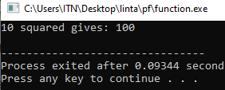**#include<iostream>**

**using namespace std;**

**int square(int);**

**int main(){**

**int a {10};**

**cout<<a<<" "<<"squared gives: "<<square(a)<<endl;**

**}**

**int square(int x){**

**return x*x;**

**}**

**QUESTION NO 15**

**#include <iostream>**

**using namespace std;**

**inline double cube(const double side)**

**{**

**return side * side * side;**

**}**

**int main()**

**{**

**double sideValue;**

**cout << "enter the side length of your cube: ";**

**cin >> sideValue;**

**cout << "volume of cube with side " << sideValue << " "**

**<< "is"**

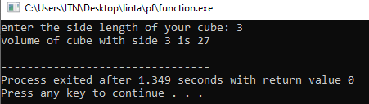**<< " " << cube(sideValue) << endl;**

**}**

**QUESTION NO 16**

**#include <iostream>**

**using namespace std;**

**int square(int x)**

**{**

**cout << "square of integer" << x << "is";**

**return x * x;**

**}**

**double square(double y)**

**{**

**cout << "square of double " << y << "is";**

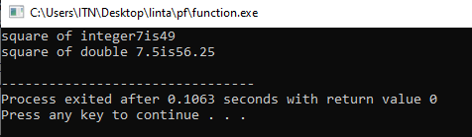**return y * y;**

**}**

**int main()**

**{**

**cout << square(7);**

**cout<<endl;**

**cout<<square(7.5);**

**cout<<endl;**

**}**

**PREVIOUS Qs BY USING FUNCTIONS**

**QUESTION NO 17**

**#include<iostream>**

**using namespace std;**

**char week(int n);**

**main()**

**{**

**int x;**

**cout<<"enter number from 1 to 7: ";**

**cin>>x;**

**week(x);**

**return 0;**

**}**

**char week(int n)**

**{**

**switch(n){**

**case 1:**

**cout<<"monday";**

**break;**

**case 2:**

**cout<<"tuesday";**

**break;**

**case 3:**

**cout<<"wednesday";**

**break;**

**case 4:**

**cout<<"thursday";**

**break;**

**case 5:**

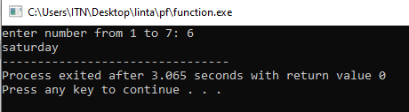 **cout<<"friday";**

**break;**

**case 6:**

**cout<<"saturday";**

**break;**

**case 7:**

**cout<<"sunday";**

**break;**

**}**

**}**

**QUESTION NO 18**

**#include<iostream>**

**using namespace std;**

**int roman(int n);**

**main()**

**{**

**int x;**

**cout<<"enter number from 1 to 10: ";**

**cin>>x;**

**roman(x);**

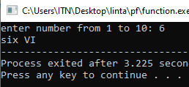 **return 0;**

**}**

**int roman(int n)**

**{**

**switch(n){**

**case 1:**

**cout<<"one I" ;**

**break;**

**case 2:**

**cout<<"two II";**

**break;**

**case 3:**

**cout<<"three III";**

**break;**

**case 4:**

**cout<<"FOUR IV";**

**break;**

**case 5:**

**cout<<"five V";**

**break;**

**case 6:**

**cout<<"six VI";**

**break;**

**case 7:**

**cout<<"seven VII";**

**break;**

**case 8:**

**cout<<"EIGHT VIII";**

**break;**

**case 9:**

**cout<<"NINE IX";**

**default:**

**cout<<"TEN X";**

**}**

**}**

**QUESTION NO 19**

**#include<iostream>**

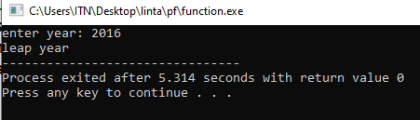**using namespace std;**

**int year(int n);**

**main()**

**{**

**int x;**

**cout<<"enter year: ";**

**cin>>x;**

**year(x);**

**return 0;**

**}**

**int year(int n)**

**{**

**switch(n%4){**

**case 0:**

**cout<<"leap year";**

**break;**

**deafult:**

**cout<<"not a leap year";**

**} }**

**QUESTION NO 20**

**#include<iostream>**

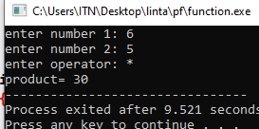**using namespace std;**

**int op(int a,int b,char c);**

**main()**

**{**

**int x,y;**

**char z;**

**cout<<"enter number 1: ";**

**cin>>x;**

**cout<<"enter number 2: ";**

**cin>>y;**

**cout<<"enter operator: ";**

**cin>>z;**

**op(x,y,z);**

**return 0;**

**}**

**int op(int a,int b,char c)**

**{**

**switch(c){**

**case '+':**

**cout<<"sum= "<<a+b;**

**break;**

**case '-':**

**cout<<"sub= "<<a-b;**

**break;**

**case '*':**

**cout<<"product= "<<a*b;**

**break;**

**case '/':**

**cout<<"divide= "<<a/b;**

**break;**

**deafult:**

**cout<<"invalid ";**

**}**

**}**